No exceptions! You must show all work and/or explain your answers to receive full credit.
( 10 points- 1point per question)
Please Note : It is recommended that you print and write out your answers. Scan/take a photo and upload to the drop-box in Unit 2, Lesson 9 Slide 4. (You may use extra paper as needed – make sure it is uploaded as well.)

Lesson 1-1. Draw a net for the figure.
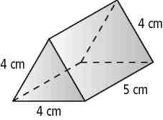
1.

Lesson 1-2.
2. 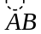 and 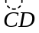 do not intersect but 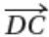 intersects in one point. Make a sketch that shows this.

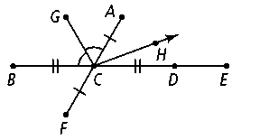
Lesson 1-3 and 1-4. Simplify.
3. If BC = 12 and CE = 15, then BE = 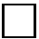.

4. If AC = 5x − 16 and CF = 2x − 4, then AF = .

Lesson 1-5. Name the angle(s) in the diagram described by each of the following.

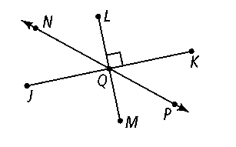
5a. supplementary to ∠NQK __________

5b. vertical to ∠PQM __________

5c. congruent to ∠NQJ __________

Lesson 1-6. Construct the perpendicular bisector of segment AB.

6.

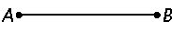

Lesson 1-7. Find the distance between the two points. Round to the nearest tenth.
.
7. R(5, 2), S(−2, 4) 8. A(-7, -3), S(−5, 4)

Lesson 1-8. Name the polygon. Identify the sides and angles. State whether it is concave or convex.

9.
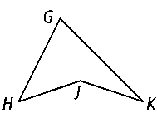

Polygon name: ______________________________

Sides: ______________________________________

Angles: ____________________________________

Concave or Convex?

Lesson 1-9. Find the perimeter and area.

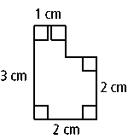
10.
Perimeter: __________________________

Area: ______________________________

